$ sudo apt-get install lua5.1
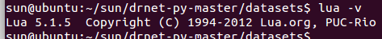


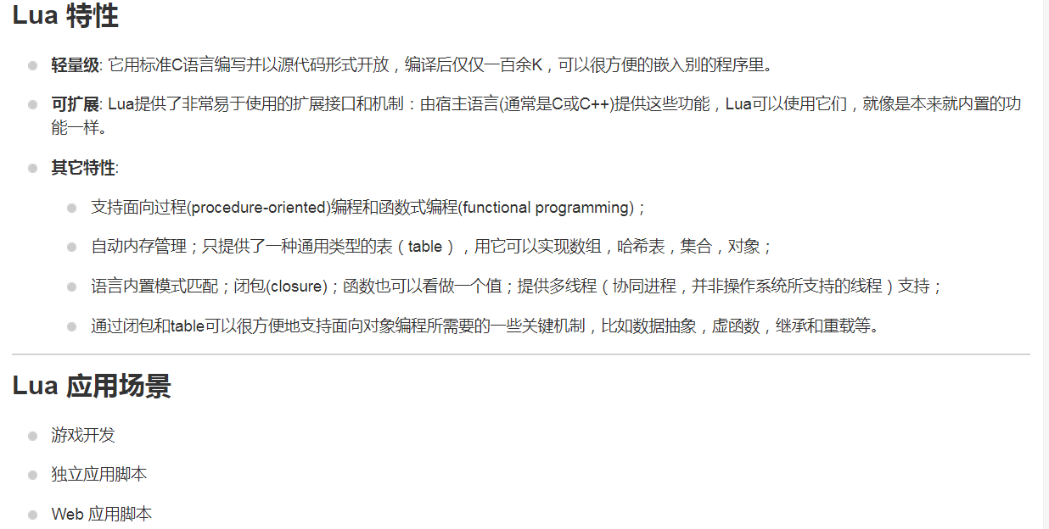

sun@ubuntu:~/sun/luascript$ lua -e 'print(55)' test.lua a b
